Chapter 4, Solution 65

At the terminals of the unknown resistance, we replace the circuit by its Thevenin equivalent.
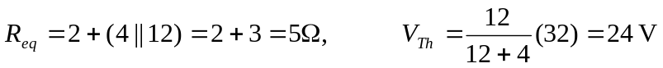
Thus, the circuit can be replaced by that shown below.

5 I_{o}

+ +
24 V V_{o}
- -

Applying KVL to the loop,

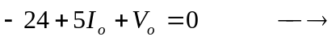 V_{o} = 24 – 5I_{o}.

